FILE CREATION TASK

1. Q1: Create a directory called ""my_folder"", navigate into it, and create a file named ""my_file.txt"" with some text. Then, create another file named ""another_file.txt"" with some text. Concatenate the content of ""another_file.txt"" to ""my_file.txt"" and display the updated content. Finally, list all files and directories in the current directory.

OUTPUTS:

#created directory myfolder

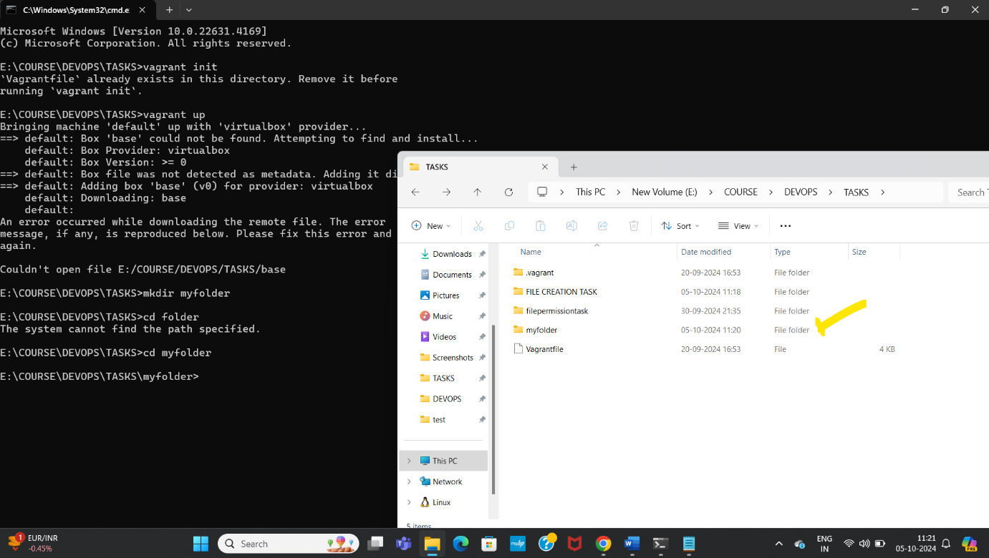

#created my_file in the directory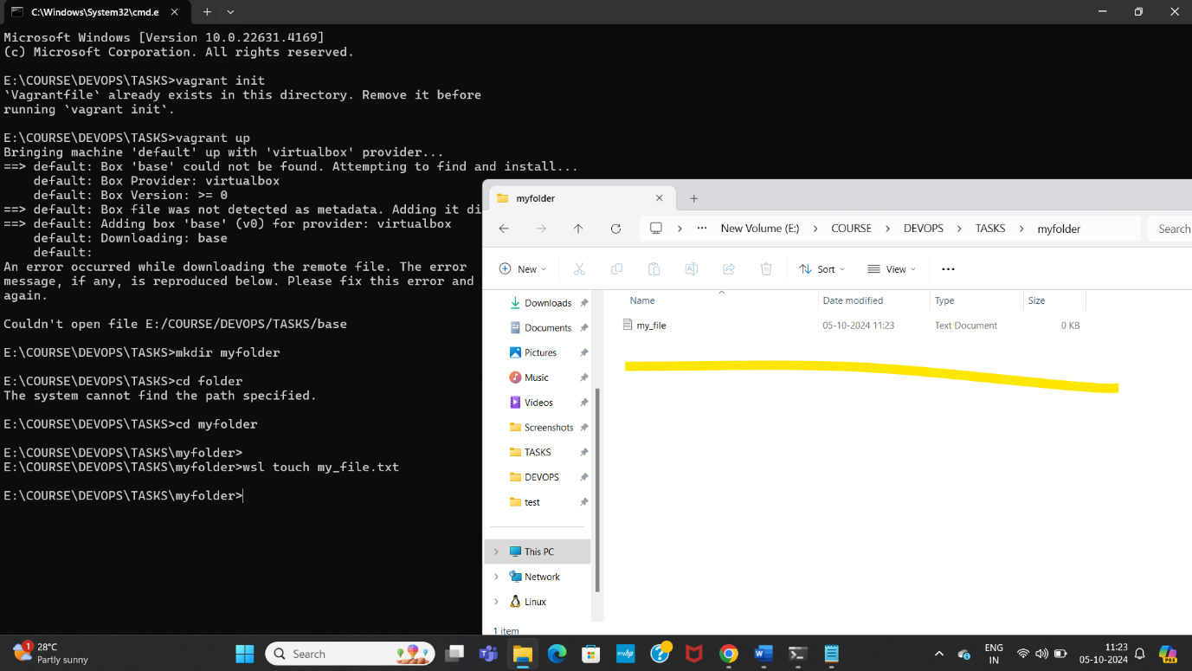

#written text in the file – my_file

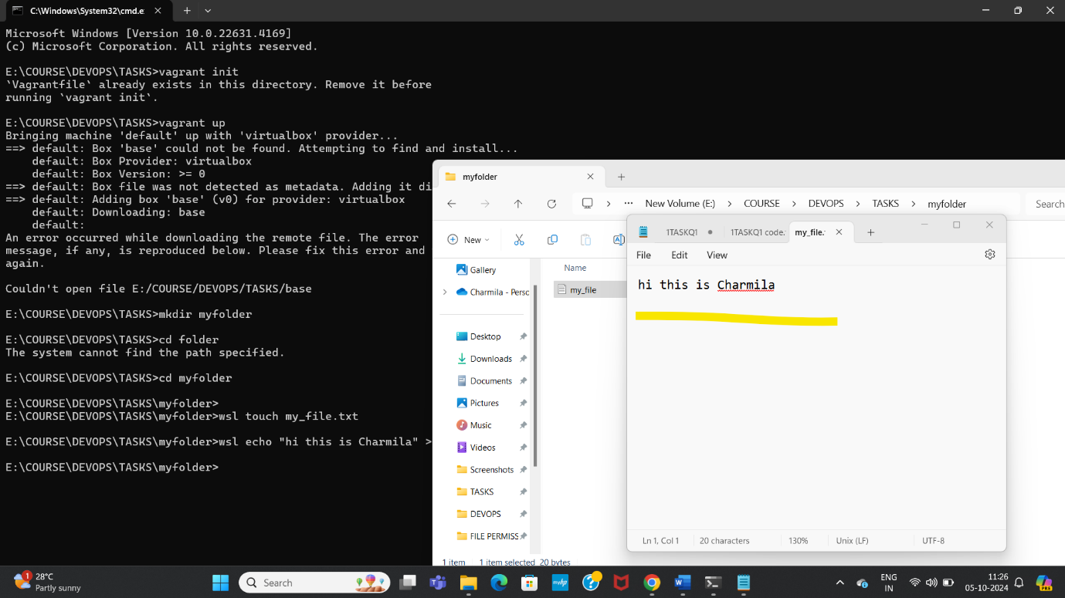

Created another file – another_file.txt

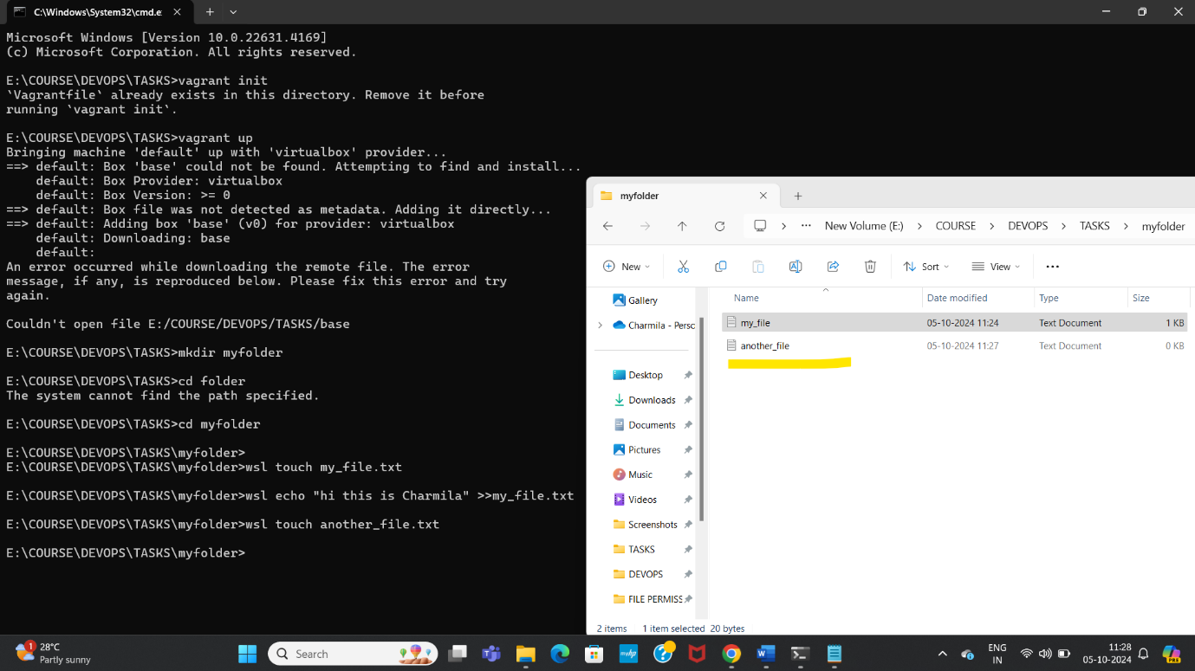

Written text in another_file.txt

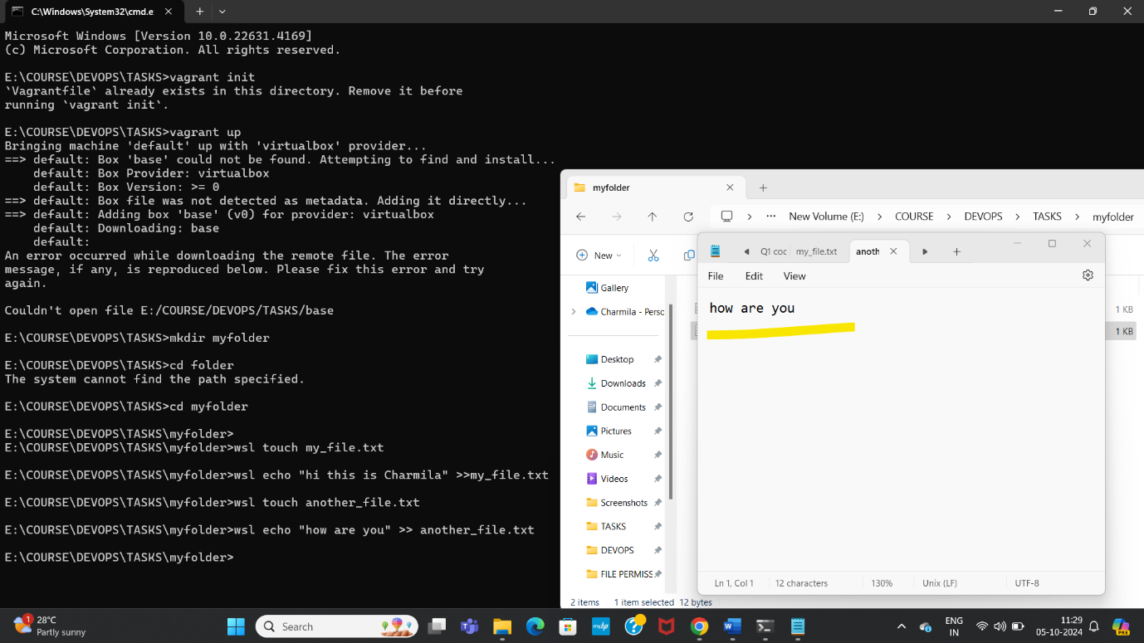

Concatenated the text in another_file.txt to my_file.txt

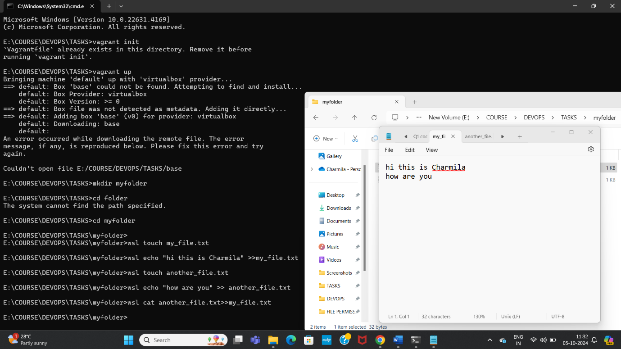

Finally displayed all files, directories in current directory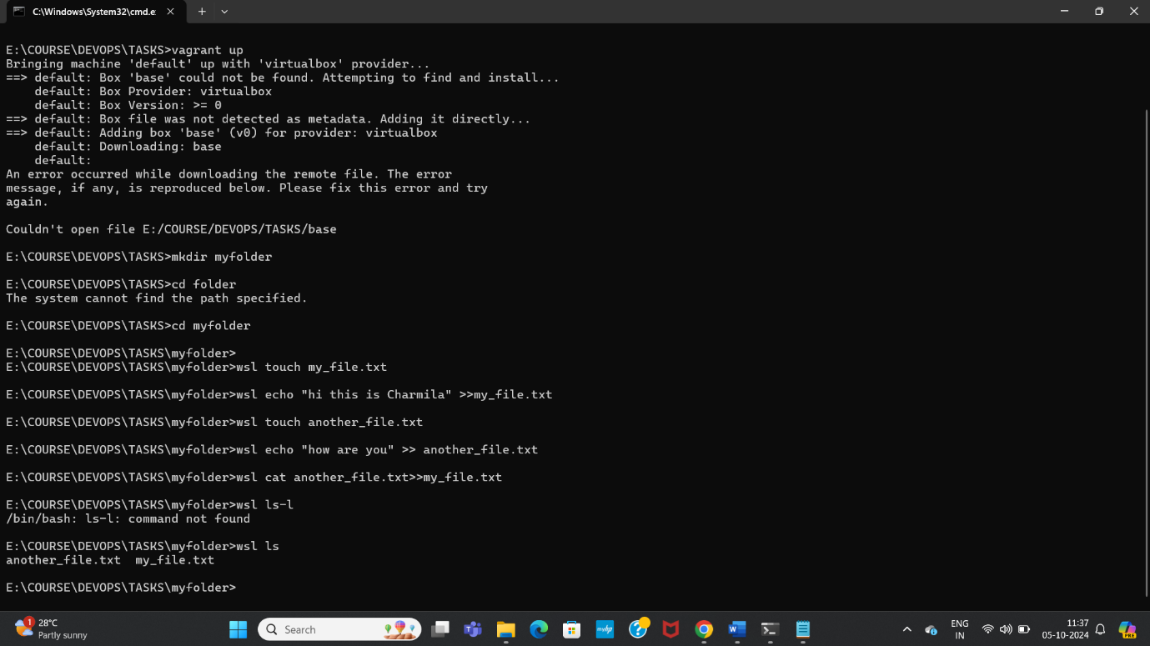

Q2: Create 20 files with .txt extensions and rename the first 5 files to .yml extension and Print the latest created top 5 files among the total no of files".

Created 20 .txt files in a directory called Q2

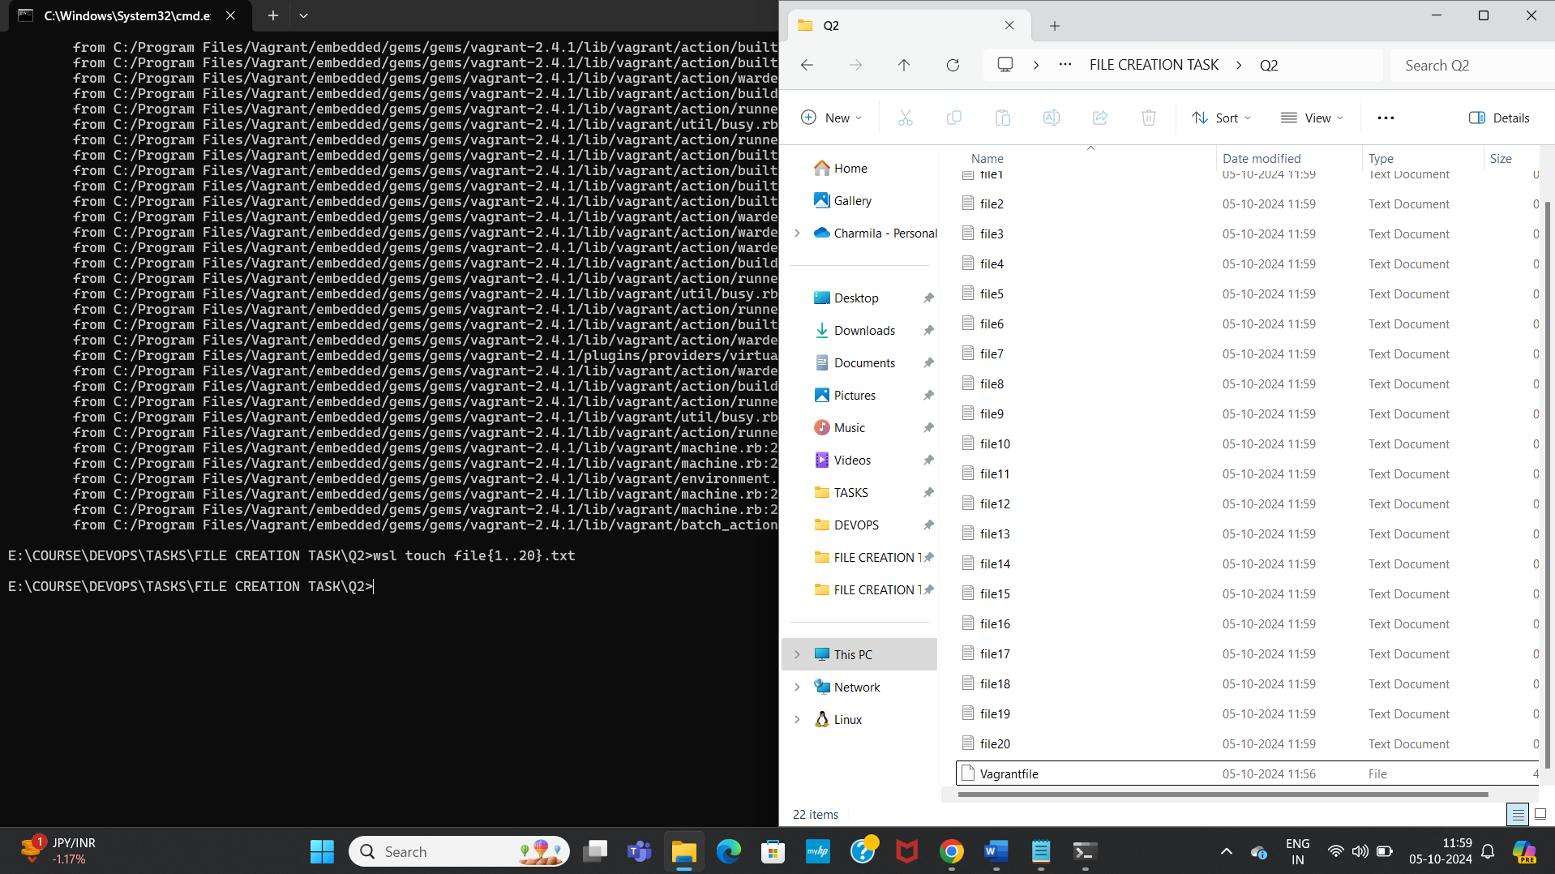

Renamed first 5 files to .yml extension

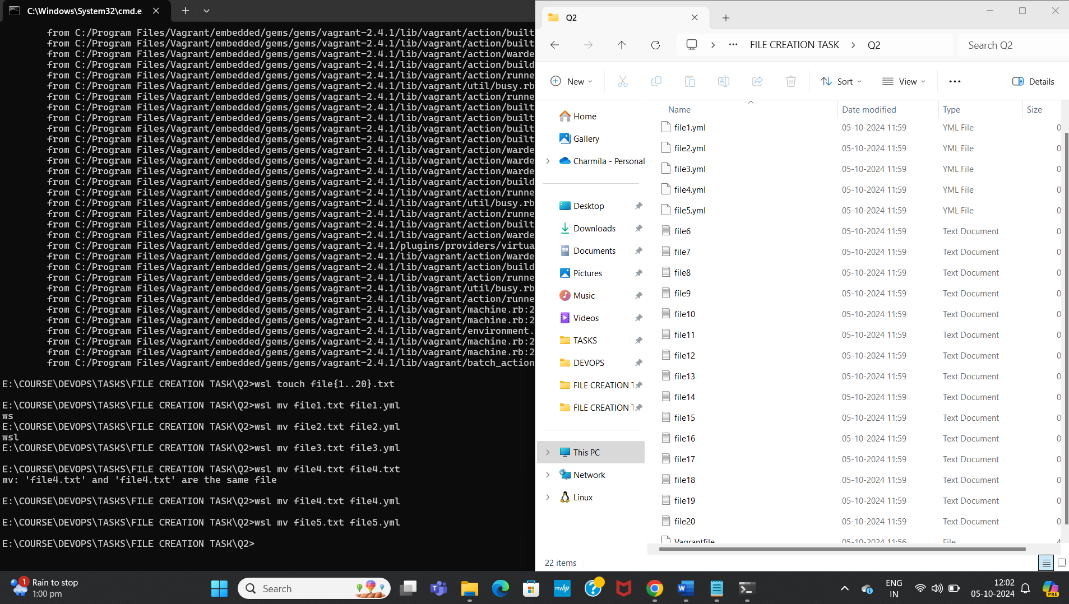

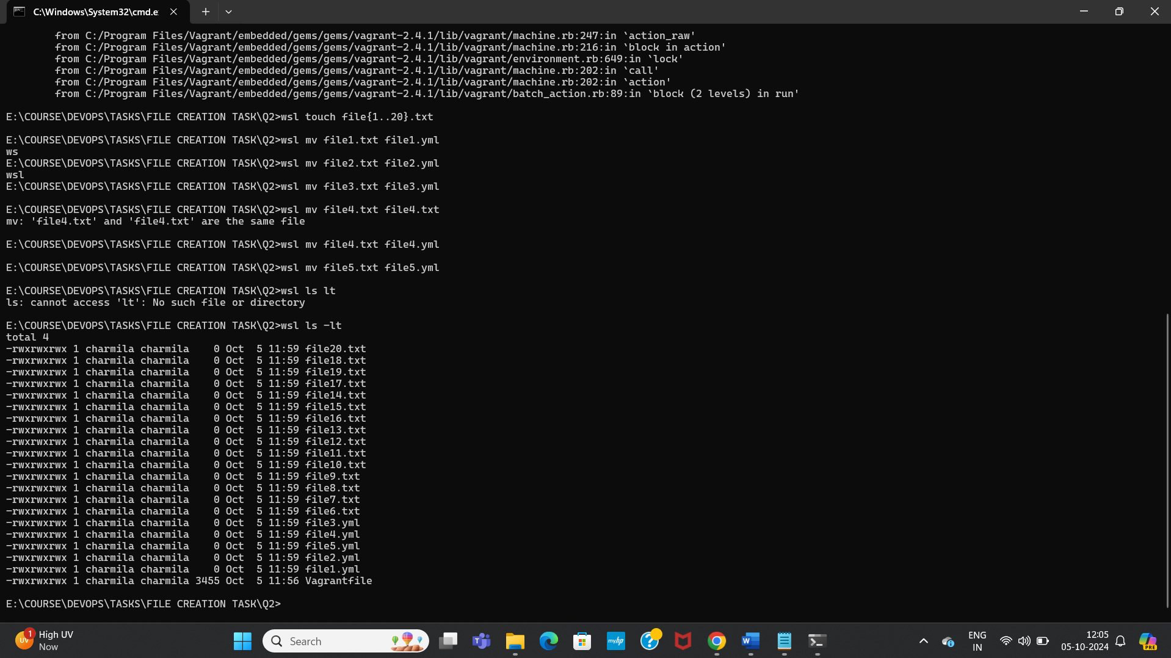

Printed latest created 5 files among total files as above